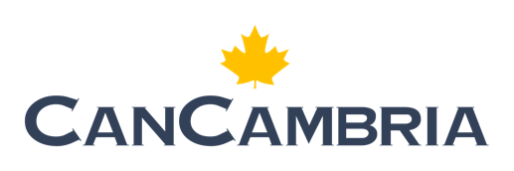

CanCambria Energy Corp.

Symbol: TSXV: CCEC | OTCQB: CCEYF
Market Cap: 73M
Sector: Energy
Purpose: Raise Awareness / Open Market Buying

CanCambria Energy Corp. is a Canadian-based exploration and production company specializing in tight gas development. With a globally experienced leadership team, CanCambria focuses on high-quality, de-risked projects with direct access to profitable markets. Leveraging industries; most advanced technologies they aim to commercialize their flagship asset, the 100% owned Kiskunhalas Project in southern Hungary, a significant gas-condensate resource in the heart of Europe.

Investor Highlights;

- Low risk appraisal / development of a large liquids-rich gas project in a proven basin in Central Europe.
- Excellent fiscal terms and commodity pricing with available infrastructure to speed development and maximize investor returns.
- Led by a management team with an extensive track record of success developing unconventional projects.
Paul Clarke – President & CEO
Dr. Clarke joined CanCambria in mid-2022 as VP of Exploration and has 25 years of experience in the oil and gas industry. One of the E&P industry’s leading unconventional experts, a “blue-ribbon” oil and gas finder and developer. Dr. Clarke has deep technical and broad operational proficiency, leading complex teams and having held roles of increasing responsibility with large-cap U.S. independents. At the forefront of several major onshore exploration, appraisal, and development programs. Operated assets include the Eagle Ford and Spraberry/Wolfcamp trends, executing over 1,000 horizontal wells (with NYSE: PXD), and the giant Pinedale Field with Ultra Petroleum. Dr. Clarke has a passion for identifying opportunities and value-creation via the drill-bit. As a practical technical leader, his strengths include creativity and problem-solving. His track record is defined by practical, analytical, and strategic decision-making, also working with a sense of urgency.

