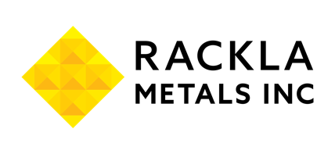

Rackla Metals Inc.
Symbol: TSXV: RAK | OTCPK: RMETF
Sector: Mining
Rackla Metals is a Canadian gold exploration company focused on discovering Reduced Intrusion-Related Gold Systems (RIRGS) in the eastern Tombstone Gold Belt, in the Yukon and the Northwest Territories. The company holds eight claim blocks, including its flagship Grad Property, where early prospecting has returned high-grade gold values. Rackla’s projects are strategically located in a newly emerged premier gold district, delivering over 17 million ounces in new discoveries since 2020—including Snowline Gold’s Valley Discovery. With a strong technical team and a commitment to systematic exploration, the company is positioned to advance its flagship Grad project and unlock the district’s gold potential.
Investor Bullet Points:
- ​​Rackla Metals is advancing its new Grad discovery, a Reduced Intrusion-Related Gold System (RIRGS) in the Tombstone Gold Belt.
- In 2024, Rackla identified a 2.93 km² unexplored Cretaceous felsic intrusion on its flagship Grad Property, with 22% of samples returning gold values between 0.5 g/t and 92.4 g/t with associate high-grade bismuth and tellurium and 1.8 g/t Au over 38 m trench
- The Grad property is drill ready, with a maiden drill program set to begin in the summer 2025 exploration season.
Simon Ridgway - CEO

Simon Ridgway is a prospector and mining financier, know for discovering major gold and silver deposits across the Americas. His career began in the 1970s as a prospector in the Yukon Territory, where he developed a passion for grassroots mineral exploration.
Over the decades, Ridgway has been instrumental in discovering significant gold deposits in Honduras, Guatemala, and Nicaragua, as well as silver deposits in Mexico. He is a founder of Fortuna Silver Mines Inc., serving as its former chairman, and founded Radius Gold Inc., where he holds the position of Executive Chairman. Additionally, he is the founder and CEO of Volcanic Gold Mines Inc. In recent years, Ridgway has come full circle, returning to Northern Canada with Rackla Metals Inc. to discover the big one.

