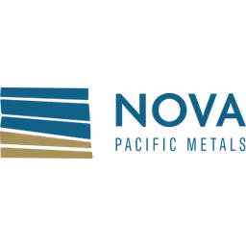

Nova Pacific Metals Corp.

Symbol: CSE: NVPC | OTCQB: NVPCF
Sector: Mining
Purpose: Raise Awareness / Open Market Buying

Nova Pacific is a Canadian exploration and development company focused on the Lara Volcanogenic Massive Sulfide (VMS) Project on Vancouver Island, British Columbia. This brownfields development project boasts a significant historic resource rich in critical and precious metals situated in a prime location with excellent infrastructure. Nova Pacific’s forward-looking strategy includes confirmation and infill drilling, completion of an updated mineral resource estimate (MRE) and preparation of a Pre-Feasibility Study if and as required

Investor Bullet Points:

- Untapped Potential: The Lara Property represents a significant opportunity in the VMS space, with historical drilling indicating mineralization that remains open for expansion.

- Data-Driven Approach: The comprehensive database update provides a solid foundation for targeted exploration, potentially leading to more efficient resource definition and expansion.

- Expanded Program: The significant increase in the planned drill program demonstrates the Company’s confidence in the project and commitment to rapidly advancing its development.

- Strategic Location: Situated in the mining-friendly jurisdiction of British Columbia, the Lara Property benefits from excellent infrastructure and proximity to major ports.

- Commodity Outlook: With the current bullish outlook for base and precious metals, Nova Pacific is well-positioned to capitalize on the growing demand for copper, zinc, and other critical minerals.

- Experienced Team: Nova Pacific’s management and technical team have a proven track record of discovery and development in the mining industry.

J. Malcolm Bell – CEO
Mr. Bell has enjoyed a career spanning over 45 years in the resource industry and is a seasoned leader with a proven track record as a principal, director, and senior officer of both private and public enterprises. In 1980, he established Hi-Tec Resource Management Ltd., a Vancouver based minerals exploration company providing geological services to clients with projects located across Canada, the western USA, Mexico and many parts of South America. His visionary spirit led to the inception of the International Investment and Business Opportunities Exposition in 1986, marking a pivotal milestone as the pioneering investment trade show company in Canada. This revolutionary platform provided private and public enterprises with an avenue to exhibit themselves on a global stage.

