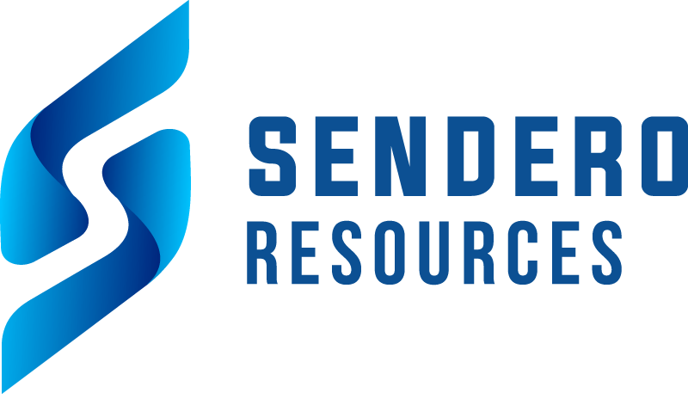

Sendero Resources Corp.

Symbol: TSXV: SEND
Market Cap: 5M
Sector: Mining
Purpose: Open Financing: .08 unit w/ 2 yr 1/2 warrant @ .12

Sendero Resources is a dynamic junior exploration company focused on unlocking the vast mineral potential of the Vicuña District in Argentina. Our flagship Peñas Negras Project encompasses a sprawling 211km2 of prime exploration territory, 120km2 of which are 100% owned by Sendero, with an option agreement in place for the remaining 91.7km2, which is directly adjacent to the original claims.
Situated in the Vicuña District, renowned for significant copper discoveries, the Peñas Negras Project is strategically surrounded by world-class super giant discoveries owned by Filo Mining, Lundin Mining, and NGEx Minerals.
The Project exhibits close geological similarities to neighboring deposits, including the prestigious Josemaria and Filo Del Sol copper-gold porphyry system and the gold-rich Maricunga porphyries.
In Sendero’s maiden drill program, a large porphyry system was discovered with porphyry related breccia and vein systems in a large mineralized lithocap. A cluster of porphyry and epithermal targets have been identified across the property, we are leveraging our experience and operational knowledge to advance exploration.

Investor Bullet Points:

- 5.3m pre-money entry to Vicuna District
- Major Porphyry System identified

- 212 kmsq property with cluster of porphyry and epithermal systems identified

Michael Wood – CEO

Michael Wood is the Co-Founder and Executive Chairman of Sendero Resources, he has extensive experience in mineral exploration space and is an advisor to Emerging Markets Capital.

