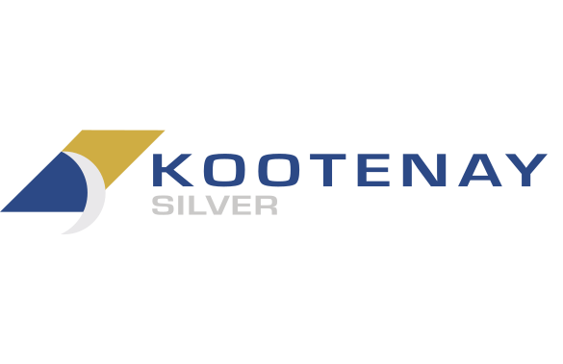
Kootenay Silver Inc.

Symbol: TSXV: KTN | OTCPK: KOOYF
Market Cap: 74M
Sector: Mining
Purpose: Raise Awareness / Open Market Buying

Kootenay Silver Inc. is a Mexican based silver exploration company actively engaged in the development of several major silver projects in Mexico, including the Columba and La Cigarra silver projects in Chihuahua, and the Promontorio and La Negra silver projects in Sonora. Drilling is currently underway at the Columba high grade silver project, where to date over 30,000 meters have been drilled and currently a 20,000 meter program is ongoing, in pursuit of a maiden resource. The Company has a leading growth profile highlighted by one of the largest junior owned silver asset bases in Mexico and a large generative portfolio of precious metals exploration projects located in Mexico.

Investor Bullet Points:

- ​​Significant leverage to silver price
- Explosive growth potential through high grade drill discoveries
- Potential for value re-rating

James M. McDonald, President, CEO & Director
Mr. McDonald has more than 30 years of combined technical and financial experience in mining sector. He co-founded and successfully developed National Gold (which merged with Alamos Minerals) to form Alamos Gold for which he was a Director and served on numerous committees until June 2012. Mr. McDonald also served as President of Genco Resources which operated the La Guitarra Silver Mine located in Mexico. Mr. McDonald is a founder of Kootenay Silver Inc. and a co-founder and former director of Northern Vertex Mining Corp.
Rajwant Kang, Chief Financial Officer & Corporate Secretary
Mr. Kang has over 25 years of financial experience and has held various senior financial positions within public and private companies including, Salares Lithium, Gryphon Gold, Star Shipping and Steppe Gold. He brings a extensive knowledge of finance, regulatory, accounting and public markets. Mr. Kang holds a CPA, CMA designation obtained in Canada and an HND in Business and Finance, obtained in the UK.
Dale Brittliffe, Vice President of Exploration
Mr Brittliffe is a professional geologist with 25 years of mineral exploration experience, working on projects in Australia, Canada, Mexico, USA and Brazil. Mr. Brittliffe has particular expertise in identifying and upgrading early stage projects and boasts a solid track record of successful stakeholder negotiations resulting in amicable and productive land access agreements. Based in Vancouver,B.C., Mr. Brittliffe has 10 years of experience managing exploration projects in northern Mexico for junior exploration companies including Kootenay Silver, Astral Mining and Orex Minerals Inc. and Silver Viper Minerals Corp. He holds a Bachelor of Applied Geology degree from Curtin University of Western Australia and a Bachelor of Science (Environmental) degree from the University of Western Australia and is a member in good standing of Engineers & Geoscientists British Columbia (EGBC).

