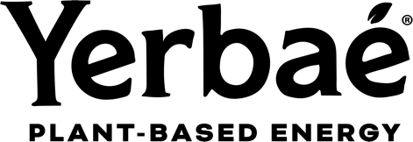

Yerbae Brands Corp.

Symbol: TSXV: YERB.U | OTCQX: YERBF
Market Cap: 36M
Sector: Food & Beverage
Purpose: Raise Awareness / Open Market Buying

Yerbaé Brands Corp. makes great-tasting energy beverages with yerba mate and other premium, plant-based ingredients. Harnessing the power of nature, Yerbaé’s celebrity ingredient (Yerba Mate) is known to produce 196 different vitamins, minerals and nutrients that also produces caffeine. All Yerbaé energy beverages are zero calorie, zero sugar, non-GMO, vegan, kosher, keto-friendly, paleo-approved, gluten free and diabetic-friendly. Founded in Scottsdale, AZ in 2017, Yerbaé seeks to disrupt the energy beverage marketplace by offering a no-compromise energy solution.

Investor Bullet Points:

- Yerbae operates in the $30 billion US energy drink market with strong gross margins exceeding 50%. Revenue growth has been significant, reaching $10 million in Q3 2023, up 90% from the previous year.
- Backed by celebrity investors from NFL, MLB, and MLS, including Kyle Shanahan, Brock Purdy, Aaron Rodgers, Giancarlo Stanton, Nolan Arenado, Kellyn Acosta, among others.
- Supported by strategic investors like the Co-Founder of Sprouts Farmers Market and Performance Food Group.
- Yerbae has secured significant retail expansion with major retailers like Target and Kroger, the largest grocery chain in North America, in 2024.

Todd Gibson – CEO

If you’ve followed the beverage industry you may have heard of Yerbae’s CEO, Todd Gibson. One of the thought leaders behind Monster Energy, SoBe, NOS Energy, and Fuze. He and his team already had four successful exits as they successfully sold these brands to Coca-Cola or Pepsi Cola.

