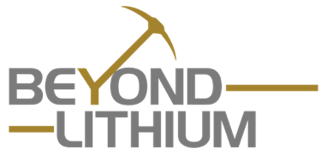

Beyond Lithium Inc.

Symbol: CSE: BY | OTCQB: BYDMF
Market Cap: 14M
Sector: Mining
Purpose: Raise Awareness / Open Market Buying

Beyond Lithium Inc. is the largest greenfield lithium exploration player in Ontario with 64 high potential greenfield lithium properties totalling over 150,000 hectares. The Company has adopted the project generator business model to maximize funds available for exploration projects, while minimizing shareholder dilution. Beyond Lithium is advancing certain of its projects with its exploration team and will seek to option other properties to joint venture partners. Partnering on various projects will provide a source of non-dilutive working capital, partner-funded exploration, and long-term residual exposure to exploration success.

Investor Bullet Points:

- Two Large Spodumene Discoveries in Same District
  - Ear Falls Spodumene Project
  - Victory Spodumene Project
  - Eight more projects in the same district

- Fast Exploration Pace Successful First Year
  - Two major spodumene discoveries
  - One pluton discovery
  - Completed Phase 1 exploration on 79.4% of projects ▪18 projects selected for Phase 2

- More Discovery Opportunities
  - 18 projects selected for Phase 2 exploration

- Compelling Valuation
  - 30.2 million shares outstanding, $9.5M market cap
  - Tight share structure

Allan Frame – President & CEO

Mr. Allan Frame serves as President, Chief Executive Officer at Beyond Lithium. Mr. Frame has extensive experience in the financial industry. He spent 47 years in the financial services industry with various Canadian Investment dealers. He retired in May of 2022. During his career he has successfully underwritten or participated in raising several hundred millions of dollars for junior resource companies, primarily in the mining sector. Mr. Frame also acts as director of business development for DLP Resources Inc and Prismo Metals.

