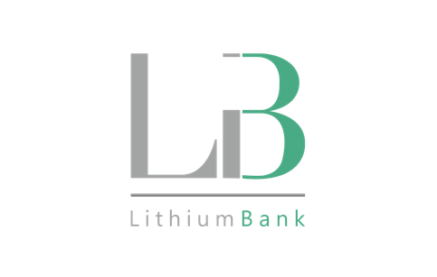

LithiumBank Resources Corp.

Symbol: TSXV: LBNK | OTCQX: LBNKF
Market Cap: 40M
Sector: Mining
Purpose: Raise Awareness / Open Market Buying

LithiumBank Resources Corp. is an exploration and development company focused on lithium-enriched brine projects in Western Canada where low-carbon-impact, rapid DLE technology can be deployed. LithiumBank currently holds over 3.2 million acres of mineral titles, 2.82M acres in Alberta and 326K acres in Saskatchewan. LithiumBank’s mineral titles are strategically positioned over known reservoirs that provide a unique combination of scale, grade and exceptional flow rates that are necessary for a large-scale direct brine lithium production. LithiumBank is advancing and de-risking several projects in parallel of the Sturgeon Lake Lithium Brine Project.

Investor Bullet Points:

- 2 district scale projects in North America

- Exclusive DLE Technology
  - Large-scale pilot stage
- Near term production

- Experience selling large scale projects to majors
  - 6 public take outs by majors totaling over $2 billion

Rob Shewchuk, Chairman & CEO

Alberta based investor with 25 years experience in the capital markets including Chairman of Standard Securities Capital Corp and Managing Director of Wolverton Securities Ltd acquired by PI Financial Corp in 2016. Rob currently serves on the Board of Directors of Graphene Manufacturing Group Pty Ltd, Spectre Capital Corp, Verses Technologies Inc and is a Partner and Director at Caerus Capital Partners Inc.

