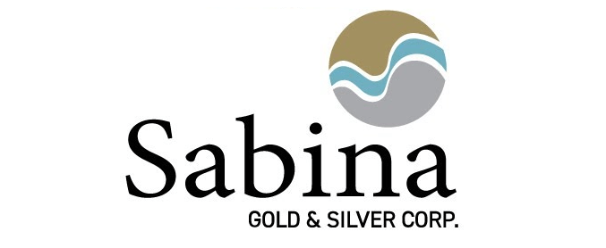

Sabina Gold & Silver Corp.

Symbol: TSX: SBB | OTCQX: SGSVF
Market Cap: 680M
Sector: Mining | Gold & Silver
Purpose: Raise Awareness / Open Market Buying

Sabina Gold & Silver Corp. is moving ahead with its Goose Mine, the first mine on its 100% owned the district scale, advanced, high grade Back River Gold District in Nunavut, Canada.

The Project has received its final major environmental authorizations, has social license and completed a US$600 million financing package in 2022. With all pre-construction activities completed and all major items procured for construction, a formal construction decision was made to begin in early 2023.

The Company continues to advance development at its Goose Mine as well as continues exploration activities on the next area of focus on the belt: the George Property.

Investor Bullet Points:

- Back River is a multi-generational Canadian mining district owned 100% by Sabina
- Established large high-grade reserves and resources with all deposits open and 80km belt mostly unexplored
- The first mine (Goose) is fully permitted with social license in hand & de-risked with significant infrastructure in place, and logistics built and tested. Full construction to begin 2023
- Full construction to begin in 2023 and set to produce ~250k oz Au over 15 years via open pit and underground

D. Bruce McLeod, Director, President & CEO
Bruce McLeod is a Mining Engineer with over 35 years of experience in all areas of the mining industry. Most recently, he was the President & Chief Executive Officer of Mercator Minerals Ltd. Prior to that, he was the President, Chief Executive Officer and Director of Creston Moly Corp. as well as a founder of both Sherwood Copper Corp and Stornoway Diamond Corporation. He also served on the Board of Directors of Kaminak Gold Corporation (acquired by Goldcorp Inc.), Palmerejo Silver and Gold Corp (acquired by Coeur D’Alene Mines) and Ariane Gold (acquired by Cambior Inc.) and has been involved in numerous projects at various stages of development while with the Northair Group. Mr. McLeod was the corecipient of -AMEBC’s EA Scholz Award for excellence in mine development in 2009 and primarily focuses on project development, strategic planning, and financing activities.
Nicole Hoeller, VP Communications
Prior to January 2008, Ms. Hoeller was Director, IR for Miramar. Along with her over 26 years of experience in investor relations and communications in the industry, Ms. Hoeller has also spent extensive time traveling in the Arctic, liaising and consulting with communities, Inuit organizations and all levels of government about the benefits and impacts of mining in Canada’s North. Ms. Hoeller also has significant experience in capital markets, corporate financing and M&A.

