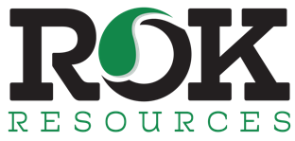

ROK Resources Inc.

Symbol: TSXV: ROK | OTCQB: ROKRF
Market Cap: 86M
Sector: Oil & Gas
Purpose: Raise Awareness / Open Market Buying

ROK Resources Inc is ~ 3500 boepd growth-oriented oil & gas company in the Kaybob area of Alberta and S.E. Saskatchewan in addition to a 25% ownership of a brine lithium play, which is yielding the highest concentrations of lithium in N.A. thus far. ROK Management has am outstanding track record of growing companies organically in SE Saskatchewan due to their technical expertise. ROK’s core focus is drilling their 100 booked locations in the Frobisher and Midale formations, two of the most economic plays in North America. The company will drill 9-11 wells this year with an expected exit rate of 4500beopd.

Investor Bullet Points:

- Proven management team

- Long-term growth and development upside

- High quality assets including exposure to lithium

Jared Lukomski – Senior VP of Land & Business Development

ROK Resources Inc is ~ 3500 boepd growth-oriented oil & gas company in the Kaybob area of Alberta and S.E. Saskatchewan in addition to a 25% ownership of a brine lithium play, which is yielding the highest concentrations of lithium in N.A. thus far. ROK Management has am outstanding track record of growing companies organically in SE Saskatchewan due to their technical expertise. ROK’s core focus is drilling their 100 booked locations in the Frobisher and Midale formations, two of the most economic plays in North America. The company will drill 9-11 wells this year with an expected exit rate of 4500beopd.

