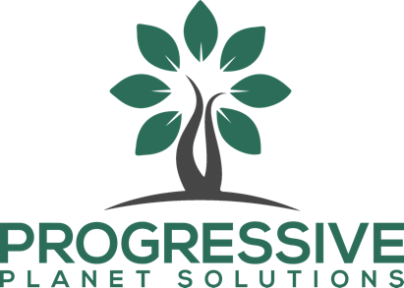

Progressive Planet Solutions Inc.

Symbol: TSXV: PLAN | OTCQB: ASHXF
Market Cap: 26M
Sector: Agriculture
Purpose: Raise Awareness / Open Market Buying

Progressive Planet (PLAN) is an established B2B manufacturer of agricultural, household and industrial products whose pioneering blue-sky technology turns post-consumer glass into high-performance cement using CO2 sequestration. Headquartered in Kamloops BC, PLAN is developing and producing a portfolio of high-demand, eco-conscious products to allow industry customers on a global scale to build, grow, live, and operate more responsibly. PLAN has 13 recognized brands found in big box retail stores, 14 organic-approved products, and a further 23 research and development projects underway focused on proprietary solutions for a $64B addressable AgTech and low carbon cement market.

Investor Bullet Points:

- Recession-proof products with good margins and growth rate

- Blue sky tech in cement with licensing and carbon credit upside

- Blue sky agtech with best-selling product patented until 2033

Stephen Harpur, CEO

A visionary leader with a passion for delivering long-term sustainable value through materials science. Steve has extensive experience in project management, corporate restructuring, applied research and development, and has achieved commercial success with numerous products while now overseeing a team of around 60 employees at PLAN.

