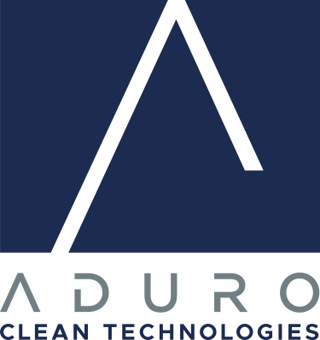

Aduro Clean Technologies Inc.

Symbol: CSE: ACT | OTCQB: ACTHF
Market Cap: 92M
Sector: Clean Technology
Purpose: Raise Awareness / Open Market Buying

Aduro Clean Technologies is a chemical technology company developing a novel technology platform that transforms low-value materials into higher-value resources with the aim of unlocking significant environmental and economic benefit. Staying ahead on a strong path for executing revenue generating projects and to better accommodate potential customers, Aduro is advancing its pilot programs and increasing its lab space. In addition, Shell has accepted the company into its innovative Shell GameChanger program for technology evaluation. On the customer side, two large global petrochemical leaders, representing a significant influence in the chemicals and plastic sector, as well as a large global food packaging company have just joined the Aduro customer engagement program. With this the Aduro team is growing, and the company just recently announced the onboarding of Eric Appelman as Chief Revenue Officer, heading up the customer engagement program. Aduro Clean Technologies has the potential for unlocking significant value as the company continues to execute.

Investor Bullet Points:

- Developer of patented water-based technologies to chemically recycle waste plastics; convert heavy crude and bitumen into lighter, more valuable oil; and transform renewable oils into higher-value fuels or renewable chemicals.

- The Company’s Hydrochemolytic™ technology relies on water as a critical agent in a chemistry platform that operates at relatively low temperatures and cost, a game-changing approach that converts low-value feedstocks into resources for the 21st century.

Ofer Vicus – Co-Founder & CEO

Ofer is CEO and Co-founder of Aduro Clean Technologies, formerly known as Aduro Energy, Inc., since its launch in November 2011. With over 20 years of experience in developing and marketing innovative technologies, he is driving the company with passion and energy, leading and guiding Aduro through its journey from the start. He has extensive business knowledge in alternative approaches to petrochemical processes with a focus of limiting environmental impact of the traditional chemical and petrochemical industries. He has distinguished himself through his ability to bring ideas to reality with advanced academic research, strong intellectual property foundations, supported by government programs and industry partners with strong orientation on the company human assets. Off the Aduro court, Ofer is big on family and a fanatic tennis player. He loves the waters including windsurfing, rowing and is a veteran open water SCUBA diving instructor.

