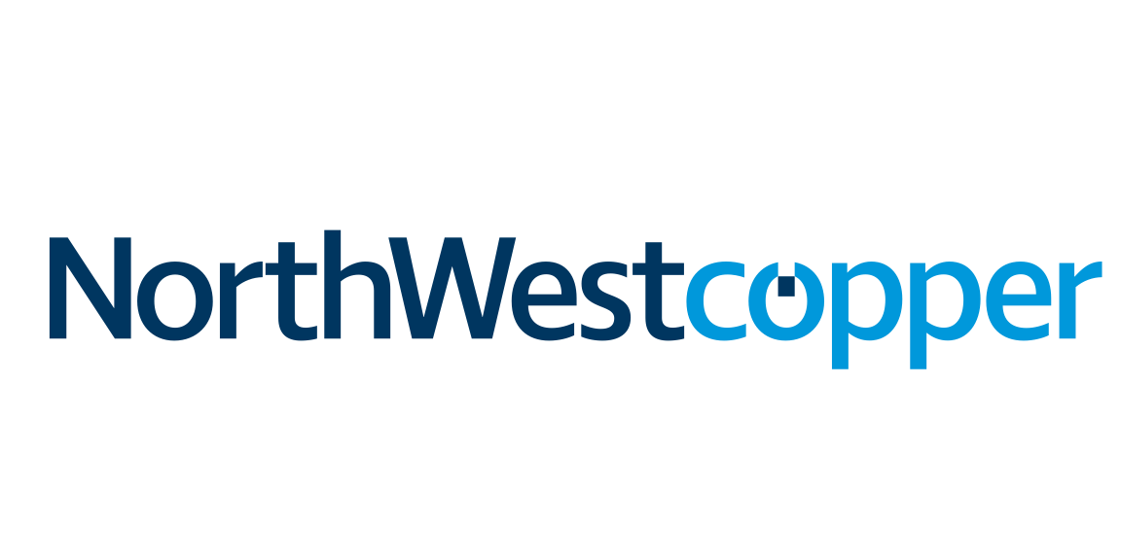

NorthWest Copper Corp.

Symbol: TSX.V: NWST | OTCQX: NWCCF
Market Cap: 64.3M
Sector: Mining | Copper
Purpose: Raise Awareness / Open Market Buying

NorthWest Copper is a new premier copper-gold explorer and developer with an exciting and diversified pipeline of projects in British Columbia, from advanced to first discovery. The creation of NorthWest Copper facilitated the consolidation of contiguous projects, including our flagships Kwanika and Stardust, which combined to form a single, larger advanced-stage copper-gold exploration project providing high-grade and critical mass. With a robust portfolio in a tier one jurisdiction, Northwest Copper is well positioned to participate fully in a strengthening global copper market. Additional information can be found on the Company’s website at www.northwestcopper.ca .

Investor Bullet Points:

- Portfolio of projects from advanced exploration to first discovery – fully funded with $18.5M cash balance

- High-grade project built around the Stardust and Kwanika deposits, with a central processing facility, low capital intensity

- Stardust is one of the highest-grade copper deposits in B.C.: Stardust has 5X the average reserve grade of current copper mines in BC.

- Kwanika has a high-grade core and is already one of the largest copper projects in BC.

- Exploration pipeline including a potential new copper-gold porphyry discovery at East Niv and a new resource at Lorraine

- Tier 1 Jurisdiction: Located in British Columbia between Mount Milligan and Kemess.

- Part of Mark O’Dea’s Oxygen Capital group – Pure Gold, Discovery Metals, and Liberty Gold. Sold Fronteer Gold to Newmont, Aurora to Paladin, True Gold to Endeavour and created 3 new gold mines in the last 5 years.

- Experienced Management: Peter Bell has over 16 years of experience as a geologist with companies such as Newmont, as well as 13 years spent as an analyst, portfolio manager, and investment banker with National Bank.

Peter Bell, B.Sc, M.Sc, P.Geo: — President & CEO
Peter Bell has over thirty years of successful experience in mining geology, mining investment and mining banking. Mr. Bell worked as a geologist in northern Ontario, Nevada, Nunavut, Tanzania, Peru and Denver, including 13 years with Newmont Corporation. He was part of the Leeville Deposit discovery team in Nevada, the Chief Mine Geologist at the Yanacocha Mine and global corporate development geologist in Denver. In 2008, Mr. Bell joined London based hedge fund MKM Longboat as a mining analyst. He built a strong track record as an analyst and investor, becoming Co-Chief Investment Officer for the Mining Equities strategy at Polygon Global Partners in 2012. While at Polygon he also co-founded private equity mining group Hawkes Point Capital. In 2018, Mr. Bell joined National Bank Financial in Toronto, providing mining project due diligence for corporate lending before moving to investment banking. As an investment banker he advised mining clients in corporate strategy, financing and M&A. Mr. Bell is a Professional Geoscientist registered in the Northwest Territories and sits on the Finance and Taxation Committee of the PDAC. He has a BSc in Geology from Western University, MSc (Minex) in Geology from Queens University and a Graduate Certificate in Finance from The University of Denver.

