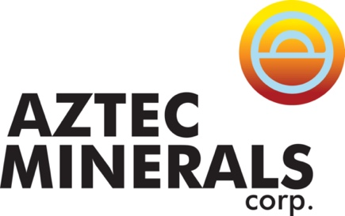
Aztec Minerals Corp.

Symbol: TSXV: AZT | OTCQB: AZZTF
Market Cap: 18M
Sector: Mining
Purpose: Open Market, Potential Financing

Aztec is a mineral exploration company focused on two emerging discoveries in North America. The Cervantes project is an emerging porphyry gold-copper discovery in Sonora, Mexico. The Tombstone project is an emerging Gold-Silver discovery with high grade CRD silver-lead-zinc potential in southern Arizona.

Investor Bullet Points:

- Experienced Management and Directors, successful track records for discovering orebodies, operating mines and selling companies
- Attractive Valuation, C$21.3 Million Market Cap with 101.6 million shares issued, Insiders own 15%, Closely-held 28%, Alamos Gold investment

- Two Prospective Projects, Cervantes in Sonora (100% owned) and Tombstone in Arizona (75% JV interest)

- Emerging Porphyry Gold Discovery on the Cervantes property at the California target, wide open for expansion

- Emerging Gold-Silver Discovery on the Tombstone Property around Contention Pit, wide open for expansion

- Prospective CRD polymetallic mineralization at Tombstone property similar to Taylor discovery (100 million tonnes of 10% ZnEq) located 60 km SW of Tombstone, purchased for $1.8 billion by South32

Simon Dyakowski – President, CEO & Director

Mr. Dyakowski brings to Aztec over 15 years of corporate development and capital markets experience, with an expertise in strategic planning and execution, financing, and marketing of exploration companies.
Mr. Dyakowski most recently acted as an adviser to TSX Venture Exchange listed mineral exploration companies on their corporate development strategies. Mr. Dyakowski holds an MBA from the University of British Columbia, is a CFA charter holder and holds an undergraduate finance degree from the University of Western Ontario. He previously worked at the Bank of Tokyo-Mitsubishi UFJ and Royal Bank of Canada dealing with investment-grade and mid-market Canadian corporate clients. Mr. Dyakowski has also worked in the equity research and equity sales departments at Salman Partners and Leede Financial.

