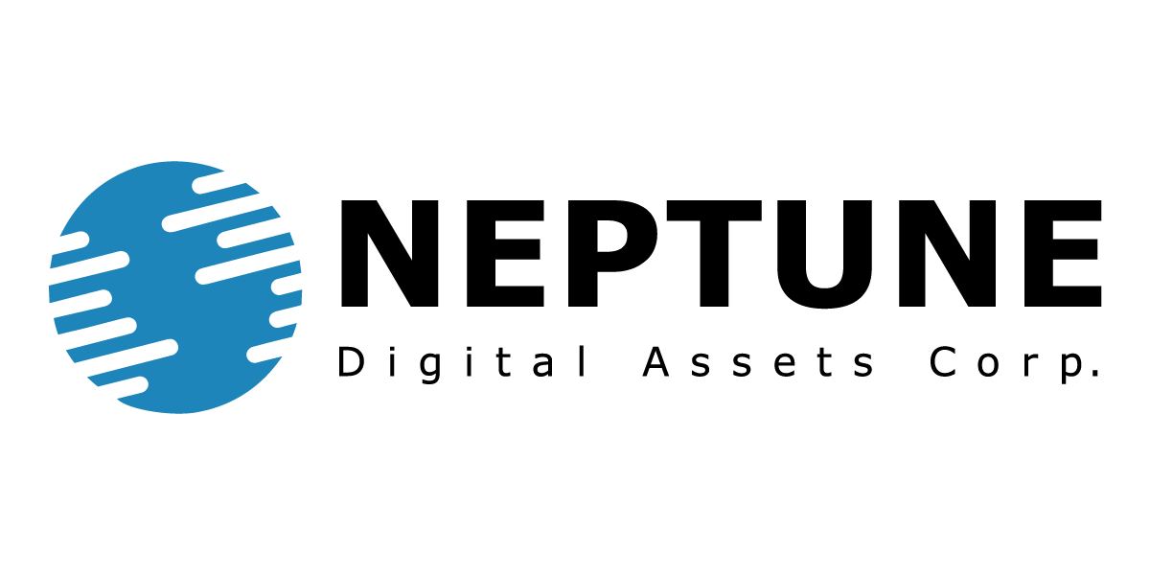

Neptune Digital Assets Corp.

Symbol: TSXV: NDA | OTCQB: NPPTF
Market Cap: 50M
Sector: Blockchain / Crypto
Purpose: Raise Awareness / Open Market Buying

Neptune is one of the first publicly traded blockchain companies
listed on the TSX-V in 2018.

Neptune's core mission is to increase revenue and value within the
proof-of-stake ecosystem and grow its Bitcoin treasury.

Investor Bullet Points:

- Generates revenue through Bitcoin mining, blockchain nodes, staking, and DeFi

- Diversified portfolio of cryptocurrencies with compounding growth

- Proven and sustainable growth with minimal operating costs

Cale Moodie – CEO & Director

Entrepreneur and CPA with 15 years in executive roles in public markets, over $200M raised,
cryptocurrency background since 2013.

Dustin Zinger – Investor Relations

Since 2017, Dustin has been actively involved in the cryptocurrency and blockchain space, helping investors bridge the gap between traditional public markets and digital assets.

