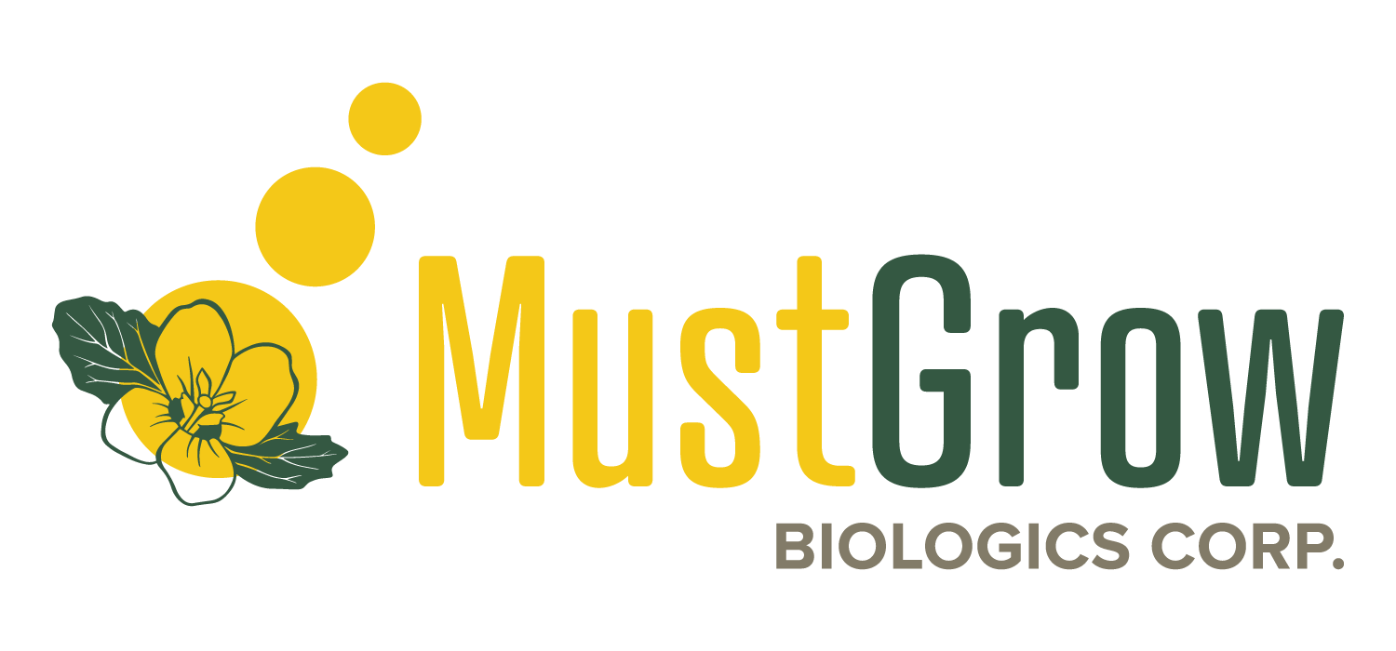

MustGrow Biologics Corp.

Symbol: CSE: MGRO | OTCQX: MGROF
Market Cap: 171.7M
Sector: Biotech
Purpose: Raise Awareness / Open Market Buying

MustGrow is a publicly traded agriculture biotech company focused on providing natural science-based biological solutions for high value crops, including fruits & vegetables and other industries. MustGrow has designed and owns a U.S. EPA-approved natural solution that uses the mustard seed’s natural defence mechanism to protect plants from pests and diseases. The product, in granule format, is EPA-approved across all key U.S. states and by Health Canada’s PMRA (Pest Management Regulatory Agency) as a biopesticide for high value crops such as in fruit & vegetables. MustGrow has now concentrated a mustard extract biopesticide in liquid format, TerraMG, and with regulatory approval, could be applied through standard drip or spray equipment, improving functionality and performance features.

Investor Bullet Points

- Providing a natural, organic crop protection platform with the potential to replace synthetic chemicals.

- Mustard plant-derived ingredients harness the natural defense mechanism of the mustard seed to control microbial diseases, pests and weeds.

- Recently partnered with global trading giant Sumitomo Corporation to fund and drive field development and regulatory work necessary for commercialization.

Corey Giasson, President, CEO & Director

Corey is an entrepreneur who has been focused on the agriculture, potash, oil and gas, mining, and real estate industries specifically in his home province of Saskatchewan, for the past 20 years. He is co-founder and director of Legacy Capital Corp., which is a private equity company focused on participating in management buyouts of strong sustainable cash flowing businesses.

In 2009, Corey co-founded a Saskatchewan based heavy oil company, Rallyemont Energy Inc., where he served as President and CEO. Rallyemont successfully explored for and delineated the Prince Thermal Heavy Oil Project and sold to Husky Energy in December 2013. Prior to Rallyemont, Corey was an independent consultant to a group of companies, including PanWestern Energy Inc. (TSXV-PW), Infrastructure Materials Corp. (OTCBB-IFAM), and Anglo Potash Ltd. (TSXV-AGP), which was formerly Anglo Minerals Ltd. (TSXV-ALM). At Anglo, he held the title of Vice President, Business Development and Investor Relations and was instrumental in marketing the company across Canada and into Europe. Anglo was acquired by its joint venture partner, BHP Billiton, in July 2008 for $284 million.

Prior to joining Anglo, Mr. Giasson was employed by PotashCorp, where he held the title of Manager, Market Research. He has a MBA and B.Sc. in Agriculture Economics, both from the University of Saskatchewan.

